**Testing SOAP and RESTful services**

**SOAP**:

This part is to get you to see how SOAP requests and responses are formatted and finding those items in a WSDL.

1. Download and install SoapUI Open Source from (should be on lab computers): <https://www.soapui.org/downloads/soapui.html>
2. Click on “Soap” to create a new Soap Project and type: <https://graphical.weather.gov/xml/SOAP_server/ndfdXMLserver.php?wsdl> into the “Initial WSDL” box, check the “Create sample requests for all operations” if not already checked and then click “OK”.
3. Expand the **LatLonListZipCode** method, double click on **Request 1** and enter a zipcode: (**Note**: if SoapUI puts localhost in the url, replace it with: [**https://graphical.weather.gov/xml/SOAP_server/ndfdXMLserver.php**](https://graphical.weather.gov/xml/SOAP_server/ndfdXMLserver.php)**). Don’t remove any other fields if they exist.**

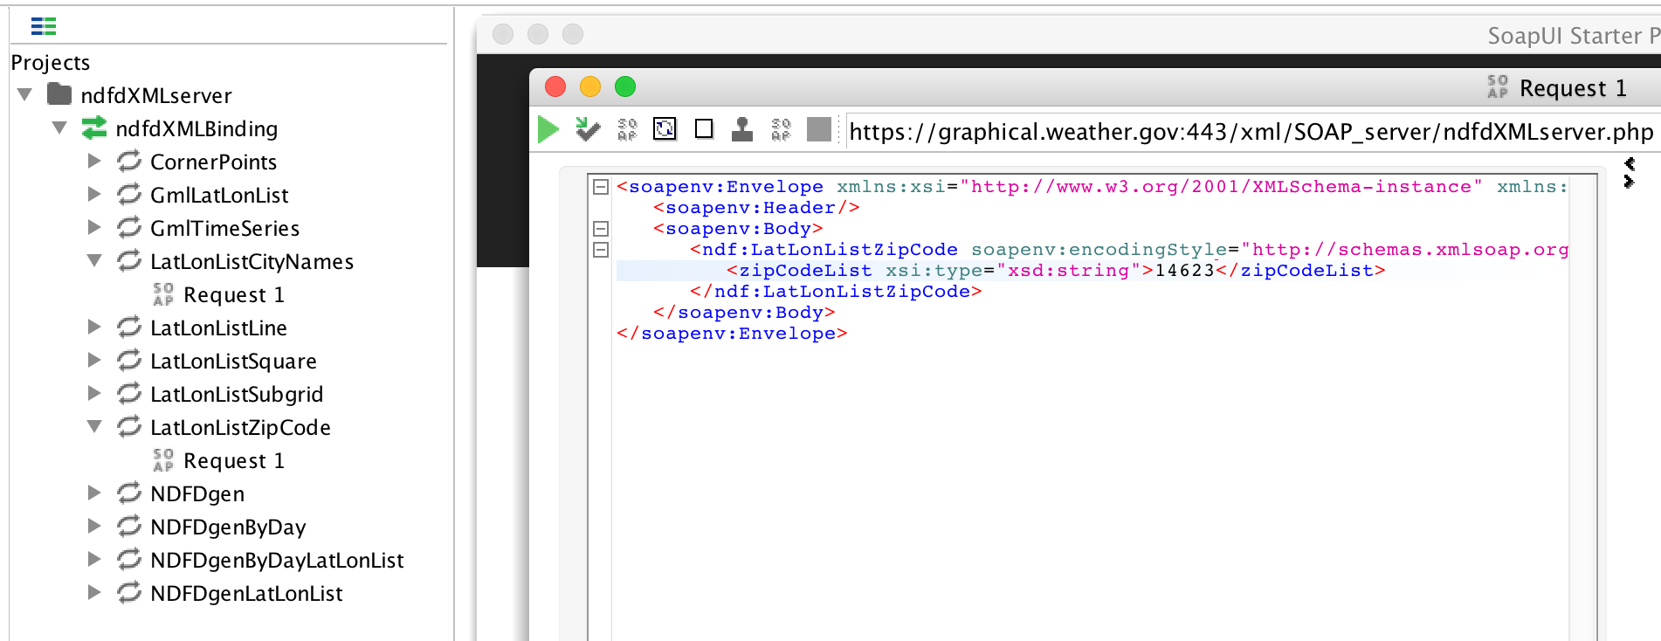

Click the green triangle to run the request, copy and paste the XML result here (click on the XML tab between the request and response windows to format the xml) :

1. Expand the **NDFDgenByDay** method, double click on **Request 1** and enter the **latitude** and **longitude** returned in the last step, enter a **startDate** in the format **yyyy-mm-dd** (make sure the date is in the near future), enter a number for **numDays**, enter **e** for **Unit** (for US Standard or **m** for Metric), then enter either **12 hourly** or **24 hourly** for **format**.
2. Click the green triangle to make the request and paste the XML result here:
3. Now change the request so that you have an invalid value for one of the fields (e.g. enter an ‘a’ for the longitude) and paste the Soap Fault XML here:
4. Open <https://graphical.weather.gov/xml/SOAP_server/ndfdXMLserver.php?wsdl> in a browser.
5. Copy and paste the 2 **message** elements for the **NDFDgenByDay** method (one request and one response):
6. Copy and paste the entire **operation** element under the **portType** element with a name of “**ndfdXMLPortType**” for the **NDFDgenByDay** method:
7. Do the same for the entire **operation** element under the **binding** element with a name of “**ndfdXMLBinding**” for the **NDFDgenByDay** method:
8. Copy and paste the soap:address element that gives the url/location of the service:

**RESTful**:

This part is to see how to use Postman to test a RESTful service and compare the responses to the SOAP responses.

1. Go to <https://www.getpostman.com/apps> and download the application for your platform (should be on lab computers).
2. Click on 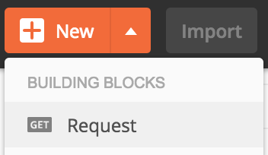 , enter “**lab**” for the **Request Name**. Click on 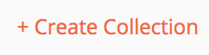 and name it **lab** as well. Select “**lab**” for the **collection** and click “**Save**”.
3. Enter <https://graphical.weather.gov/xml/sample_products/browser_interface/ndfdXMLclient.php> in the field next to “**GET**” and **listZipCodeList** as a **key** and **some zipcode** as the **value**:

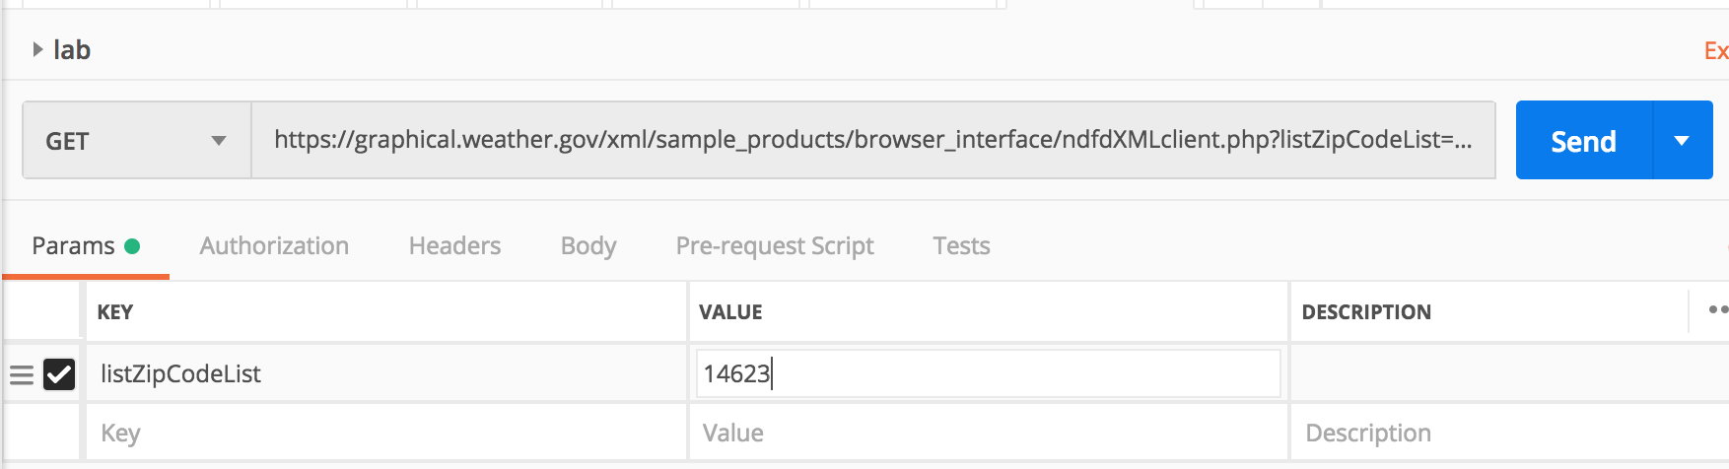

1. Click **Send** and paste the results here:
2. Uncheck **listZipCodeList**, click **Send** again and paste the error response here:
3. Add a new request and make the location: <https://graphical.weather.gov/xml/sample_products/browser_interface/ndfdBrowserClientByDay.php>  
     
   and enter the following **key**/**value** pairs: **lat**: <**latitude** returned from before>, **lon**: <**longitude** returned from before>, **format**: **24 hourly**, **numDays**: **3, unit: e**.
4. Click **Send** and paste the response here:

Put this completed Word Document in the appropriate dropbox on MyCourses.